Smart Pest Repeller

Andrew Albritton

Mequisedec Ordonez

Michael McNeil

**Concept of Operations**

REVISION

14 September 2023

Concept of Operations

for

Smart Pest Repeller

Team 30

Approved by:

_____________________________

Project Leader Date

_____________________________

Prof. Kalafatis Date

_____________________________

T/A Date

**Change Record**

| **Rev.** | **Date** | **Originator** | **Approvals** | **Description** |
| --- | --- | --- | --- | --- |
| **0** | 9/12/23 | ALL |  | Draft Release |
| **1** | 9/28/23 | ALL |  | Midterm Report ICD & FSR additions |

**Table of Contents**

**Table of Contents** **3**

**List of Tables** **4**

**List of Figures** **5**

**1.** **Executive Summary 6**

**2.** **Introduction 7**

2.1. Background 7

2.2. Overview 7

2.3. Referenced Documents and Standards 7

**3.** **Operating Concept 8**

3.1. Scope 8

3.2. Operational Description and Constraints 8

3.3. System Description 8/9

3.4. Modes of Operations 9

3.5. Users 9

3.6. Support 9

**4.** **Scenarios 9**

4.1. Garden or Small Outdoor Area Use 9/10

4.2. Commercial Use……………………………………………………………………………10

**5.** **Analysis 10**

5.1. Summary of Proposed Improvements 10

5.2. Disadvantages and Limitations 10

5.3. Alternatives 10

5.4. Impact 11

**List of Tables**

No table of figures entries found.

**List of Figures**

# Fig 1.1 - Subsystem Operational Flow Chart

# Executive Summary

Controlling the presence of pests is a task that can be a struggle for various different aspects of life. The goal of the Smart Pest Repeller is to address this issue as easily as possible for users while also mitigating potential hazards that come with alternative methods of pest control. The Smart Pest Repeller will utilize a camera and machine learning program in order to sense the presence of pests in the area through image processing. This will send a signal to an ultrasonic sound emitter that would activate to repel any pests that were sensed. The device will be able to function while plugged into a wall or on its own in order to maximize effective use situations. This will decrease the manpower and resources needed to address pest control in commercial, agricultural, and residential settings.

# Introduction

There are many pest control options on the market. Each of these options have some negative aspects that consumers may need to consider when deciding how to approach their pest control problems. The goal of the Smart Pest Repeller is to create the best solution to these problems while mitigating potentially negative aspects of pest control.

## Background

The current standard for pest control employed by most residential or commercial users currently is either the use of pesticides and other harsh chemicals or the implementation of different ultrasonic sound systems than the Smart Pest Repeller system. The limitations and drawbacks of these methods is what we are seeking to address with the Smart Pest Repeller. Since SPR is using image processing sensing technology to identify pests, it will not activate in the presence of humans or other pets and will instead target specific pests. This solution will mitigate the need for harsh chemical pesticides while also introducing a solution that targets specific pests and does not act as a hindrance to anything else.

## Overview

The system will use a camera connected to a controller unit that will be running a program to process the images received. When the program reads that there is a pest detected in the image it will send a signal to the ultrasonic sound emitting device that will act as the pest control mechanism. Once the pest is no longer detected in the area the system will turn off the sound emitter and wait until another pest is detected. The unit will be able to plug into the wall and run directly from wall power or be able to function disconnected from the wall on battery power as well.

## Referenced Documents and Standards

* Rechargeable [Battery Standards - Lithium, Nickel Metal Hydride, Nickel Cadmium (epectec.com)](https://www.epectec.com/batteries/battery-standards.html)
* OSHA Speaker/Workplace sound [OSHA Technical Manual (OTM) - Section III: Chapter 5 | Occupational Safety and Health Administration](https://www.osha.gov/otm/section-3-health-hazards/chapter-5)

# Operating Concept

## Scope

The proposed system will be designed primarily for outdoor use in agricultural settings, small gardens or farms. It will be able to detect medium to larger insects in addition to smaller reptiles. The camera will not be able to detect small insects such as mosquitos or small flies and will therefore not repel these. The camera will also limit when the device can be used since during night time and in low light environments visibility will be an issue for the camera used for detection. The device will have a battery that will need to be charged so it will occasionally be limited to near the home or make use of an extension cable for uses away from the home while charging.

## Operational Description and Constraints

The repeller will be used outdoors in a well-lit environment. The repeller will use a camera that captures an image of the environment about once every second and send it to a microcontroller. This will be sent to an image detection system that determines if there are any pests in the frame. If a pest has been identified in a frame the microcontroller will send a signal to a speaker that will emit an ultrasonic soundwave to repel the pest. Once a pest is out of frame the speaker stops emitting and waits until it receives a new signal to begin emitting again.

The smart repeller will be limited to environments with decent to high light exposure and will not work during times of low light visibility, at night or moments with overcast for example.

## System Description

The Smart Pest Repeller will consist of three major components; the power unit, the camera and ultrasonic transmitter interface, and the microcontroller.

The power unit can operate either plugged into a traditional wall outlet or independently via a rechargeable lithium-ion battery system. While plugged into a wall outlet, the system will be able to run while also charging the battery for possible wireless use in the future. If not connected to a wall outlet the battery will continue to power the system, the system will also keep track of the fuel levels of the battery and alert the user when a recharge is needed for the battery system.

The camera is controlled by a python program on the Coral board. This program will be automated to take a photo at 1 frame per second. The microcontroller will use a machine learning, ML, algorithm to classify objects in the image. The four choices of classification or labels for the model will be: Flies, Lizards, Rodents, and Idle. Each time an image is done processing one of the above modes will be active.

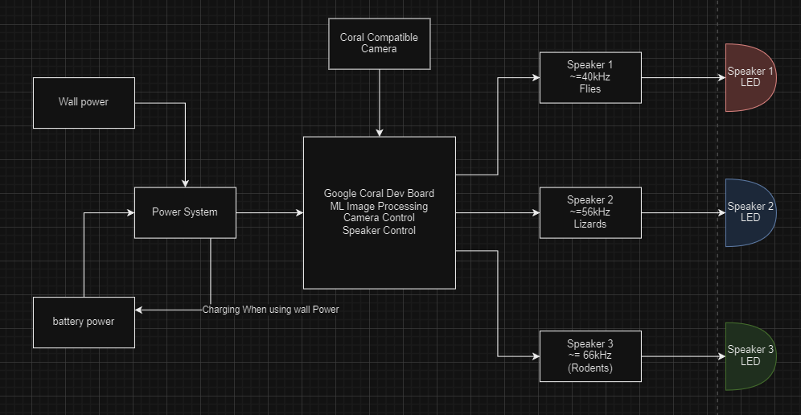

***Fig 1.1***

## Modes of Operations

The system will have one mode of operation and that will simply be “active”. In active mode the system will continuously run the camera and take in data that will be processed in real time to see if there is a pest present. Once the system detects a pest in the target area the emitter will turn on in order to remove pests from the area. Once the camera no longer detects the presence of pests, the system will turn off the emitter and continue to monitor for pests in the target area.

## Users

The Smart Pest Repeller could be marketed to any group of individuals from the individual homeowner to the commercial farmer. This is a great solution to pest control in small areas and could be deployed to cover much larger areas if multiple devices are used. It will act as an eco-friendly solution to the everyday pest problems that users may encounter.

## Support

Support for the Smart Pest Repeller will come in the form of a manual that will describe how the system works and how to operate it as well as a brief description of each subsystem in place in the system for troubleshooting purposes.

# Scenario(s)

## Garden or Small Outdoor Area Use

The Smart Pest Repeller will be best suited to smaller outdoor areas or gardens. This will be an ideal location for the SPR as the camera system will have a hard time sensing pests the further they are away so this system will be optimized for use in locations such as backyard gardens or lounge areas. The system will do great in these settings as it will likely be checked on by users more frequently than a device that is just left in the field so charging will be common enough to not be an issue. The system will also not target any pets that could be a concern for the user.

## Commercial Agriculture

The Smart Pest Repeller could also be used on bigger portions of land that would be used in farming operations but the amount of devices used may vary depending on the size of the land. Since the camera can only see so much in detail it will be more difficult to apply the camera sensing technology to a larger farm setting but if there are multiple systems in place that are strategically located, the system results should be similar to the results of using one device in a smaller area.

# Analysis

## Summary of Proposed Improvements

The recent models of “Smart Pest Repellers” are motion based, or constantly emit high frequency sound. Our device will utilize a machine learning algorithm which will differentiate between undesirable and desirable organisms. For example, a bee pollinating your garden is desirable, while a grasshopper would damage fauna. We would want to allow bees to pollinate, but if there are undesirable organisms present we will turn the high frequency emitter on.

## Disadvantages and Limitations

The disadvantages of the Smart Pest Repeller system is that since the system will be constantly running a machine learning algorithm for image processing, there will be a significant increase in power needs for the system to function. The system will also be less effective at night time since it is using image processing to detect pests and at night the camera visibility will decrease drastically. The system will also be contained in a housing unit that will take up more space than the alternative solutions such as plug-ins or citronella candles.

## Alternatives

Many alternatives to the Smart Pest Repeller already exist on the market but each of these has different limitations of their own. Pesticides are a very common solution to the pest problem, but they also have significant drawbacks in the form of polluting the environment and also exposing unintended organisms to harmful chemicals such as other humans and pets. Other ultrasonic sound repellent systems also exist but they have limitations such as always emitting, sound having to be plugged into a wall power outlet perpetually, or always emitting the same frequency (lizards, rodents, and flies react to separate frequencies: 52-60kHz, 60-72kHz, and 38-44kHz respectively)

## Impact

For the average gardener, our device will provide protection from not only flies, but rodents and lizards as well. We will be using our machine learning algorithm to differentiate between the animals listed above; this allows for differing frequency outputs from our sound source, allowing for effective pest control from most possible invaders. It can also be noted with other devices, organisms become accustomed to the constant presence of high frequency sound over time causing the device to lose its effectiveness. Our device will only trigger while there is a pest detected, this allows for an irregular pattern of sound, thus causing adaptation to the device to become more difficult for pests. High frequency pest control is considered one of if not the most humane method of pest control currently, and our device will allow for a broader range of application than the devices currently on the market.